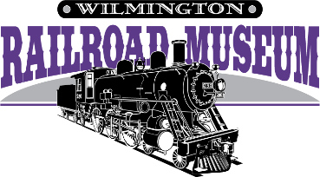
505 Nutt St.
Wilmington, NC 28401
910-763-2634 info@wrrm.org

Here is what you get for your membership!
- Recapture the spirit and heritage of historic railroad days.
- Explore a 1910 steam locomotive, boxcar with hobos, and a real caboose.
- Support children’s activities, learning, and group tours.
- Enjoy the extraordinary detail of scale model train layouts.
- Preserve documented history in our extensive library and archives.
- Join us for Members-Only events, Annual Meeting Member party, gift shop discount and more. Choose one of the following tax-deductible options with its privileges.
~~ BEST VALUE ~~
- CLUB CAR (FAMILY) - $100 Most popular option, includes benefits extended to the entire family. Admission for your immediate family, including grandparents, and big discounts on caboose parties for a full year. Most family memberships are $100 or more! This is a terrific value.
- Includes four admission tickets to the Children’s Museum!

- PULLMAN - $150: CLUB CAR benefits plus 10 passes for friends or relatives ($90 value!).
- PRIVATE CAR - $250: PULLMAN benefits plus 10 more free passes (total $180 value!).
- RAILROAD BARON - $500: PRIVATE CAR benefits plus special VIP status and early reserved seating for events.
- CHAMPION – $1000: RAILROAD BARON benefits plus your business logo as a sponsor
- COACH (INDIVIDUAL) - $60: Good for individual admission to the museum.
- - - - - - - - - - - - - - - - - - - - - - - - - - - - - - (detach here) - - - - - - - - - - - - - - - - - - - - - - - - - - - - - - - - - - -
WILMINGTON RAILROAD MUSEUM FOUNDATION, INC.
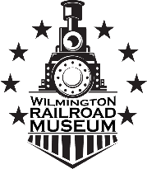
Membership Application

$100 CLUB CAR
$150 PULLMAN
PLEASE PRINT
$250 PRIVATE CAR
$500 RAILROAD BARON
$1000 CHAMPION
___$60 COACH NEW: __RENEWAL__________GIFT_________

NAME: PHONE:

ADDRESS: ________________________________

DATE OF MEMBERSHIP PURCHASE: ________________ EMAIL________________________________
GIFTOR’S NAME AND EMAIL IF APPLICABLE: _____________________________________

