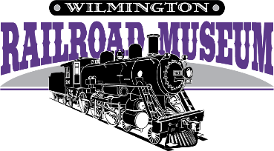
505 Nutt St.
Wilmington, NC 28401
910-763-2634 info@wrrm.org
Makes a great gift!

Help us stay on track with a membership!

- Recapture the spirit and heritage of historic railroad days.
- Explore a 1910 steam locomotive, boxcar with hobos, and a real caboose.
- Support children’s activities, learning, and group tours.
- Enjoy the extraordinary detail of scale model train layouts.
- Preserve documented history in our extensive library and archives.
- Join us for Members-Only events, like Story Time, Annual Meeting and Member party and more.

Choose one of the following tax-deductible options with its privileges.

~~ BEST VALUE ~~
- CLUB CAR (FAMILY) - $80 Most popular option, includes benefits extended to the entire family, including grandparents, and big discounts on caboose parties for a full year. Most family memberships are $100 or more! This is a terrific value.

- PULLMAN - $150: CLUB CAR benefits plus 10 free passes for friends or relatives ($90 value!).

- PRIVATE CAR - $250: PULLMAN benefits plus 10 more free passes (total $180 value!).

- RAILROAD BARON - $500: PRIVATE CAR benefits plus limited-edition of the Atlantic Coast Line History book.

- CHAMPION – $1000: RAILROAD BARON benefits plus your business logo as a sponsor

- COACH (INDIVIDUAL) - $50: Good for free individual admission to the museum.

- - - - - - - - - - - - - - - - - - - - - - - - - - - - - - (detach here) - - - - - - - - - - - - - - - - - - - - - - - - - - - - - - - - - - -

WILMINGTON RAILROAD MUSEUM FOUNDATION, INC.
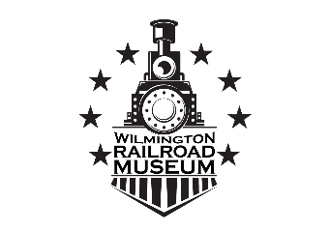
Membership Application
Thank you for your membership!
___ $80 CLUB CAR
___ $150 PULLMAN
___ $250 PRIVATE CAR
___ $500 RAILROAD BARON
___ $1000 CHAMPION
____ $50 COACH

NAME:________________________________________ PHONE:____________________________

ADDRESS:____________________________________

______________________________________________ EMAIL:_____________________________

